John Q. Student
February 12, 2014
HW 06

Table 1. Summary of Male Cholesterol Levels

Range | Bin |  |  | Cumulative
(mg/dL) | (mg/dL) | Frequency | Percent | Percent
0 - <100 | 99 | XX | XXX.XX | XXX.XX
100 - <150 | 149 | XX | XXX.XX | XXX.XX
150 - <200 | 199 | XX | XXX.XX | XXX.XX
200 - <250 | 249 | XX | XXX.XX | XXX.XX
250 - <300 | 299 | XX | XXX.XX | XXX.XX
300 - < 350 | 349 | XX | XXX.XX | XXX.XX
350 - <400 | 399 | XX | XXX.XX | XXX.XX
More | More | XX | XXX.XX | XXX.XX

Table 2. Summary of Female Cholesterol Levels

Range | Bin |  |  | Cumulative
(mg/dL) | (mg/dL) | Frequency | Percent | Percent
0 - <100 | 99 | XX | XXX.XX | XXX.XX
100 - <150 | 149 | XX | XXX.XX | XXX.XX
150 - <200 | 199 | XX | XXX.XX | XXX.XX
200 - <250 | 249 | XX | XXX.XX | XXX.XX
250 - <300 | 299 | XX | XXX.XX | XXX.XX
300 - < 350 | 349 | XX | XXX.XX | XXX.XX
350 - <400 | 399 | XX | XXX.XX | XXX.XX
More | More | XX | XXX.XX | XXX.XX

Figure 1. Distribution of Female Cholesterol Levels

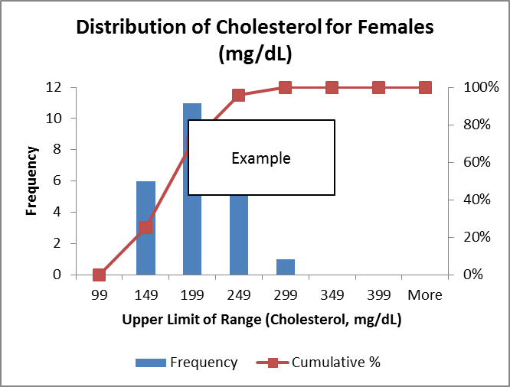

[Note: for the above I used the paste option "paste as picture" - John U.]

Table 3. Comparison of Male and Female Cholesterol Levels

Range | Male | Male | Female | Female
(mg/dL) | Frequency | Percent | Frequency | Percent
0 - <100 | XX | XXX.XX | XX | XXX.XX
100 - <150 | XX | XXX.XX | XX | XXX.XX
150 - <200 | XX | XXX.XX | XX | XXX.XX
200 - <250 | XX | XXX.XX | XX | XXX.XX
250 - <300 | XX | XXX.XX | XX | XXX.XX
300 - < 350 | XX | XXX.XX | XX | XXX.XX
350 - <400 | XX | XXX.XX | XX | XXX.XX
Total | XX | XXX.XX | XX | XXX.XX

Conclusions

(supply conclusions here)

JMP Output

(supply JMP output here)

